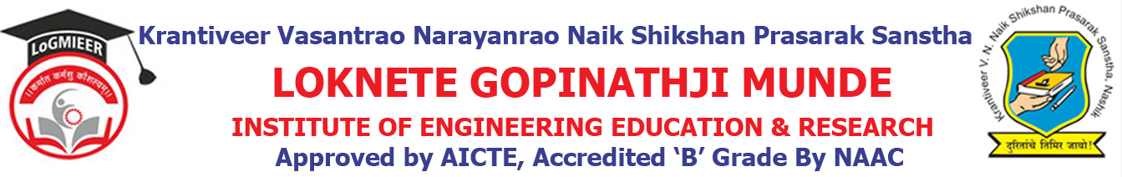
Department of AIML Engineering
ACADEMIC CALENDER-2023-24 SEM I
Sr. No. | Details of Activities | Weeks & Dates
1 | Practical Validation | Week 1 | 01/07/2023
2 | Course File & Practical File Checking | Week 1 | 01/07/2023
3 | Commencement of Teaching:TE & BE | Week 1 | 01/07/2023
4 | Commencement of Teaching:SE | Week 2 Onwards | 10/08/2023
5 | Unit Test I | Week 5 Onwards | 25/10/2023 to 31/10/2023
6 | Feedback Phase I | Week 10 | 05/11/203 to 15/11/2023
7 | In-Sem Exam | Week 11 | 14/11/2023 to 20/11/2023
8 | Expert Talk | Week 03 to Week 13 | 14/08/2023 to 24/10/2023
9 | Value Added Courses/Workshop | Week 03 to Week 13 | 12/08/2023 to 14/10/2023
10 | Industrial Visits | Week 12 | 21/10/2023
11 | Parent Meet | Week 15 | 15/11/2023
13 | Feedback Phase II | Week 16 | 31/10/2022 to 05/11/2022
14 | Final TW Sub-mission | Week 16 | 31/10/2022 to 05/11/2022
15 | Remedial classes | Week 16 | 31/10/2022 to 05/11/2022
16 | Conclusion of Academic: TE& BE | Week 21 | 04/11/2023
17 | Conclusion of Academic: SE | Week 18 to Week 21 | 04/12/2023
18 | Theory Exam | Week 19 Onwards

Prof.A.S.Nalge Prof. N. V. Kapade
Academic Co-ordinator HOD

